AWS Task - 4

Launch an EC2 instance (Linux and Windows) along with a web server. Then, create an EBS volume of 5 GB, attach it to an EC2 machine (Linux and Windows), and take a snapshot. Finally, create an EBS volume using the taken snapshot.

1.Launch EC2 Instances
1.1 Launch Linux EC2 Instance
- Go to Amazon EC2 Dashboard
- Click Launch Instance
- Configure:
- Name: Linux-Server
- AMI: Amazon Linux / Ubuntu
- Instance Type: t3.micro (Free tier)
- Key Pair: Create or select existing
- Network: Allow HTTP (80) and SSH (22)
- Click Launch Instance
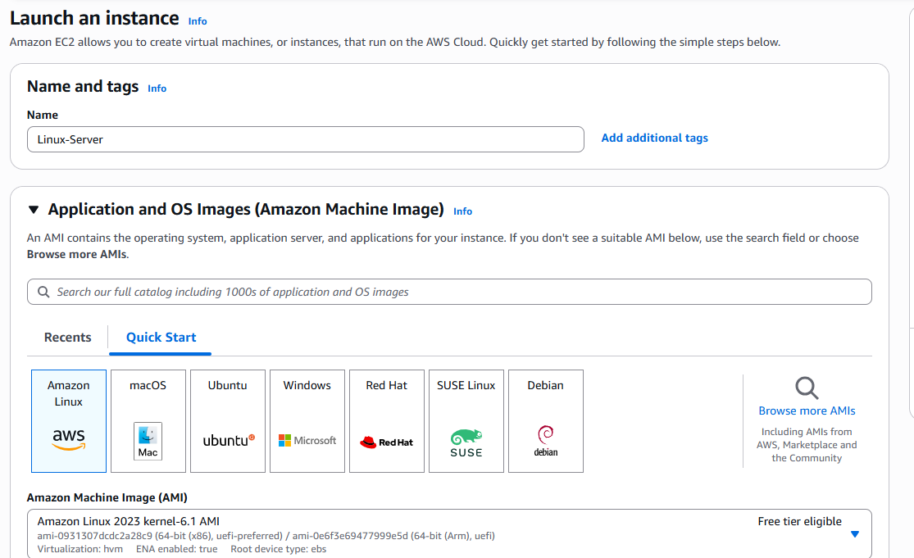

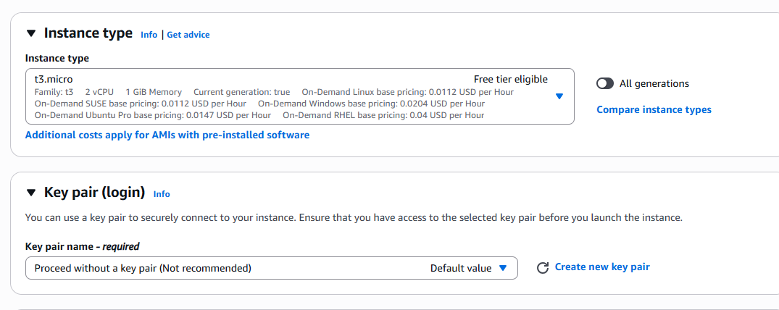
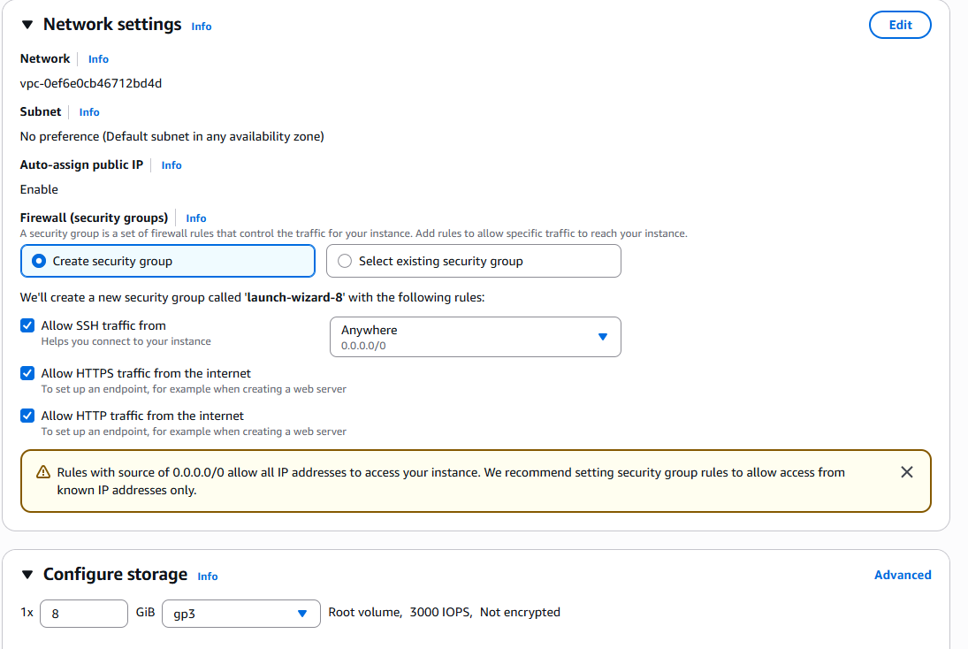

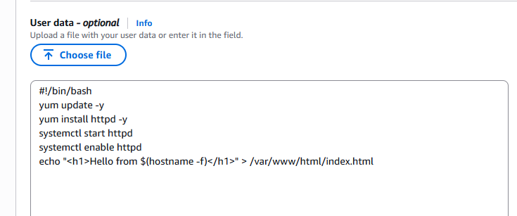
sudo yum update -y
sudo yum install httpd -y
sudo systemctl start httpd
sudo systemctl enable httpd
echo "<h1>Hello from Linux EC2</h1>" | sudo tee /var/www/html/index.html
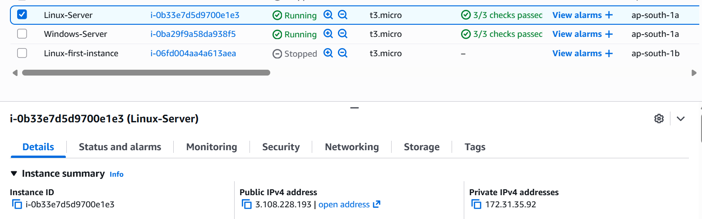

Verify Web server:
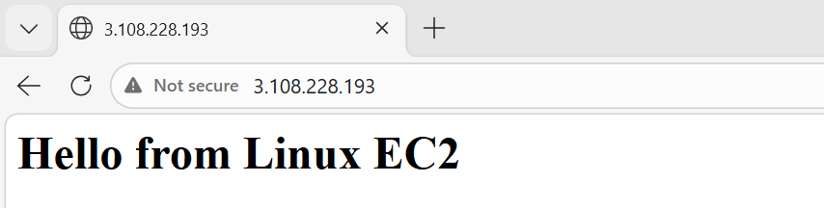

2. Launch Windows EC2 Instance
- Click Launch Instance
- Configure:
- Name: Windows-Server
- AMI: Windows Server 2019/2022
- Instance Type: t2.micro
- Allow:
- RDP (3389)
- HTTP (80)
- Launch instance
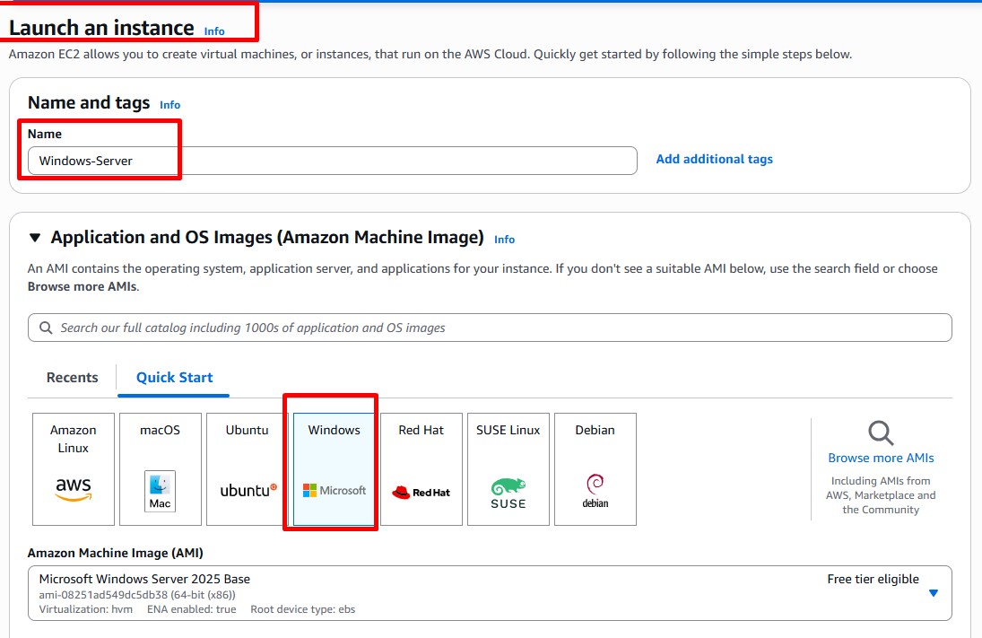

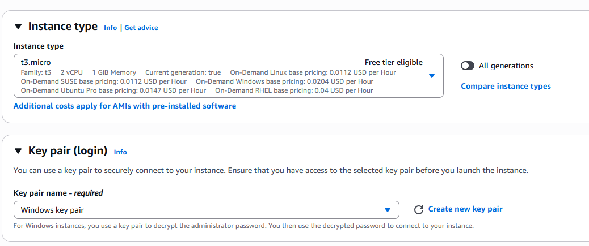

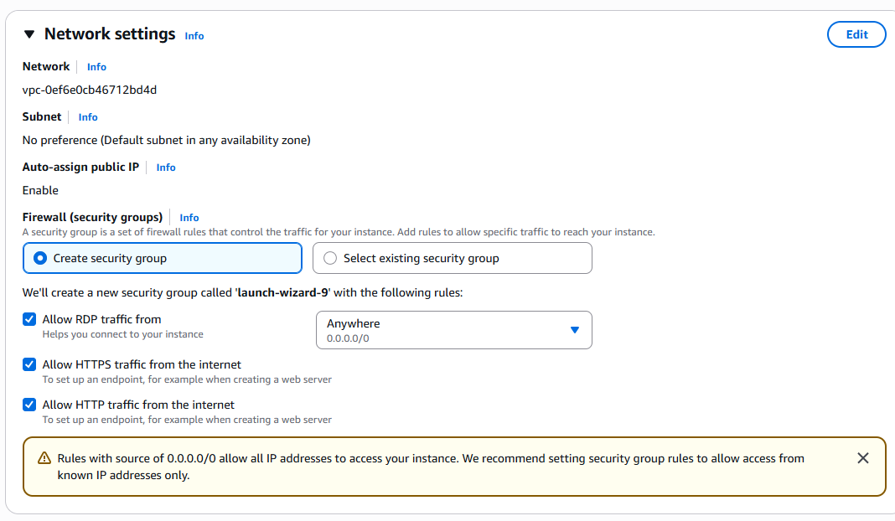

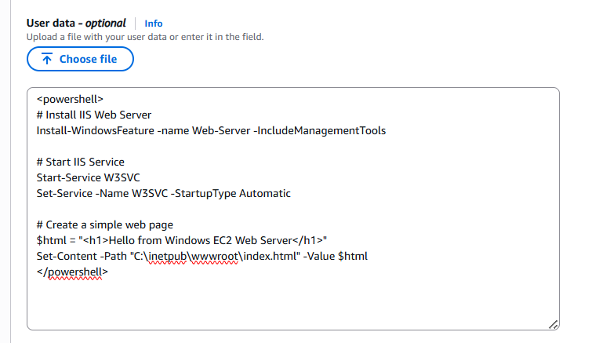
Connect to Windows Server
- Select instance → Click Connect
- Choose RDP Client
- Click Get Password
- Upload your .pem file
- Decrypt password
- Open RDP and login
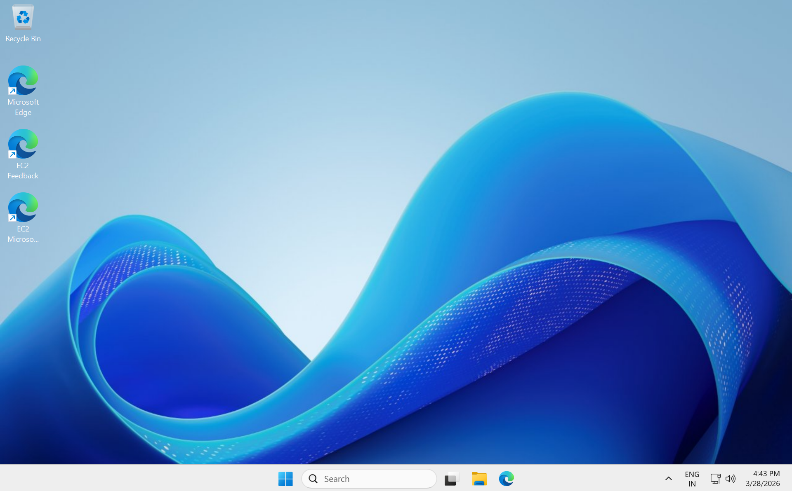
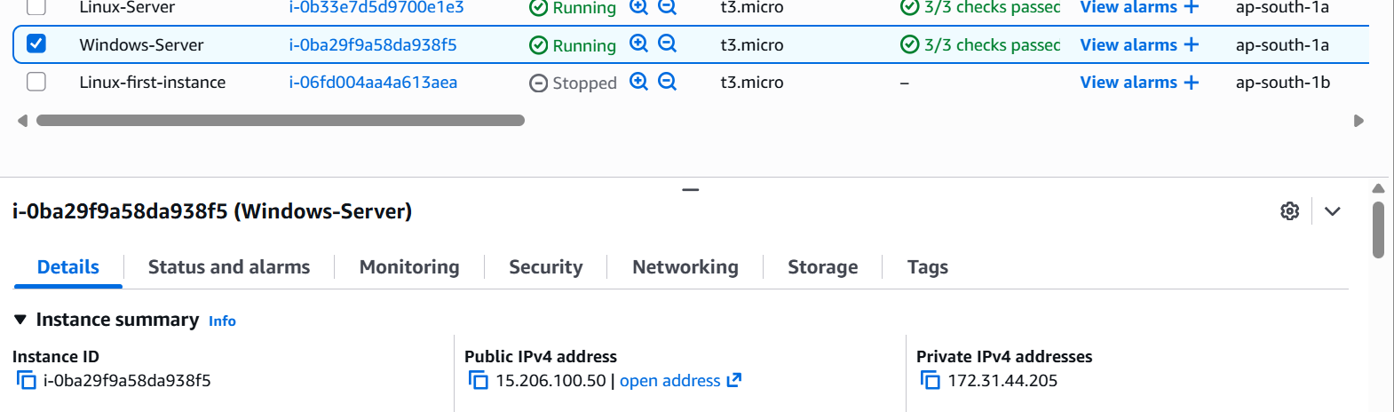
Verify Web server:
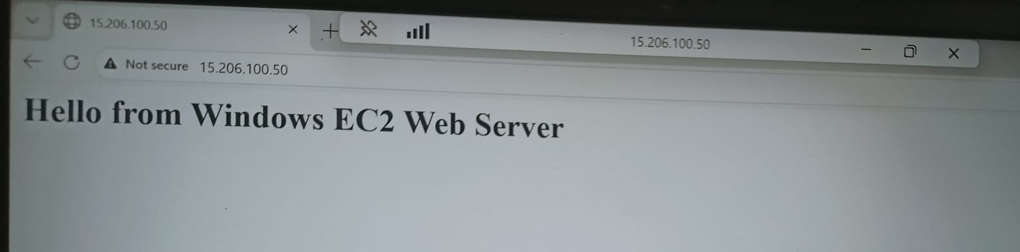

3. Create EBS Volume (5 GB)
- Go to Elastic Block Store → Volumes
- Click Create Volume
- Configure:
  - Size: 5 GB
  - Type: General Purpose (gp2/gp3)
  - AZ: Same as EC2 instance
- Click Create Volume
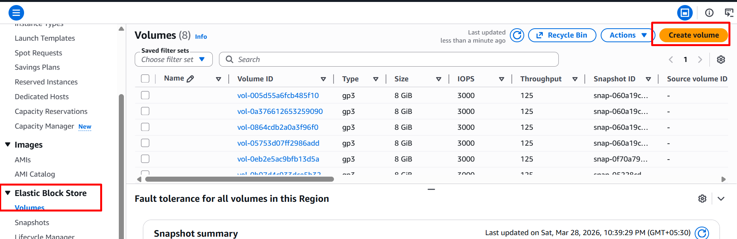

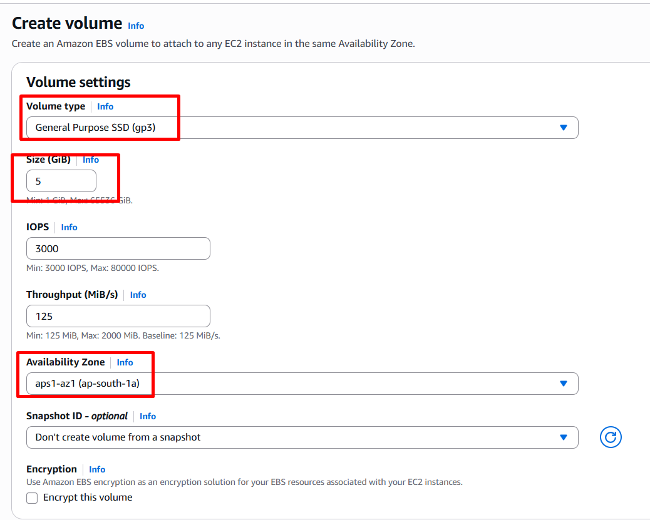

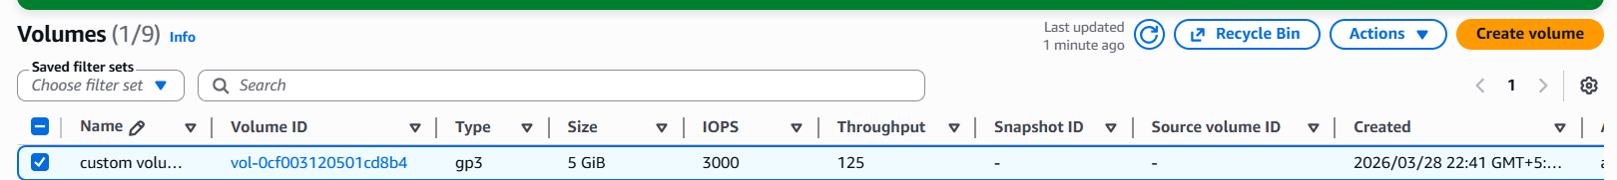

4. Attach Volume to EC2
4.1 Attach to Linux
- Select volume → Actions → Attach
- Choose Linux instance
- Device name: /dev/xvdbf
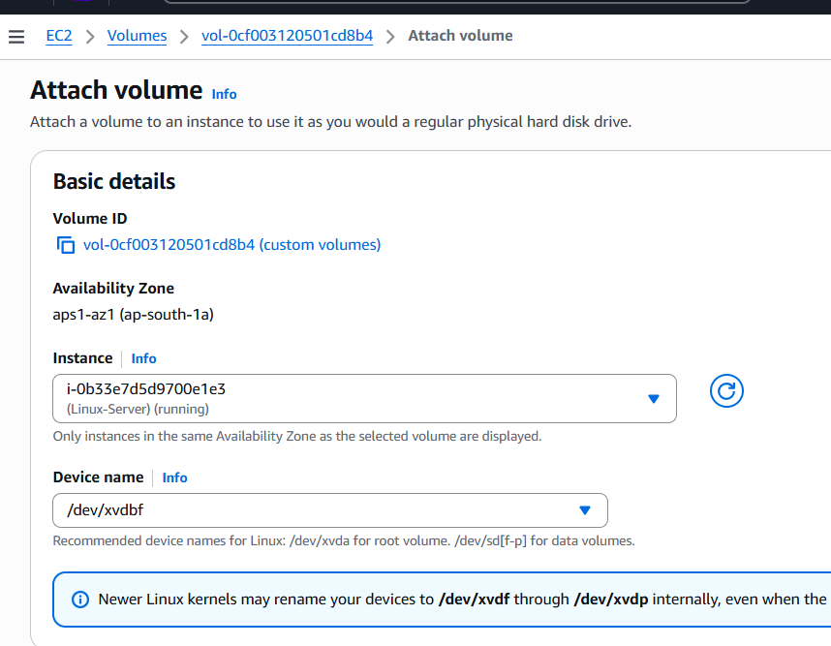
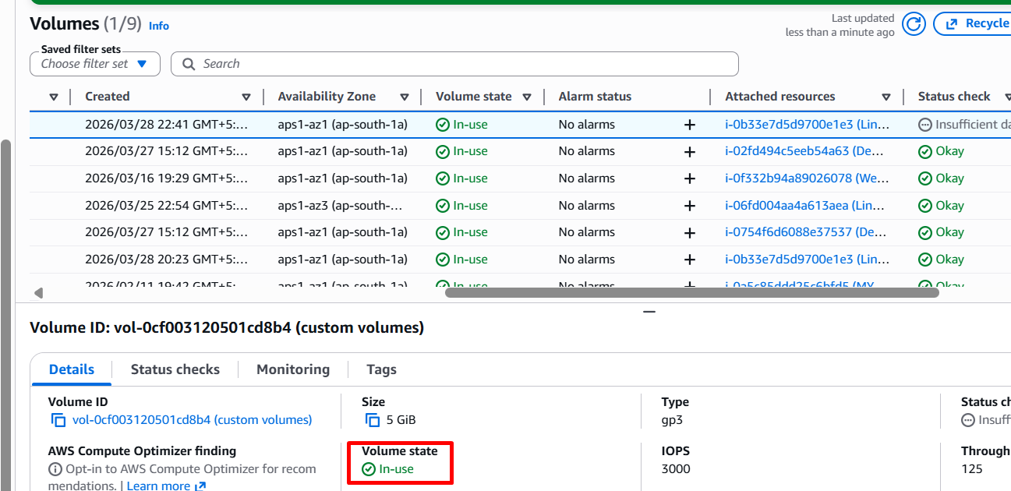
4.1.2 Configure inside Linux:
# lsblk
# sudo mkfs -t ext4 /dev/nvme1n1
# sudo file -s /dev/nvme1n1
# df -hT
# sudo echo "This data is on my EBS volume." > /data-volume/test-file.txt
# sudo su
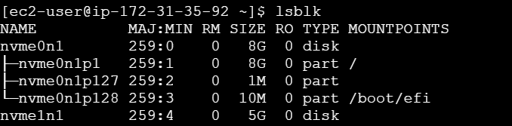
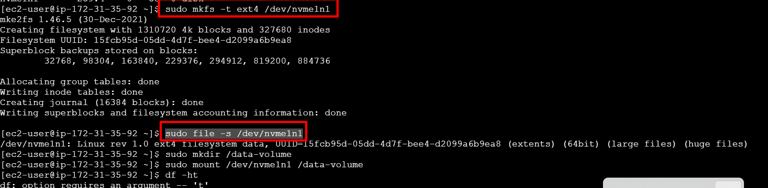
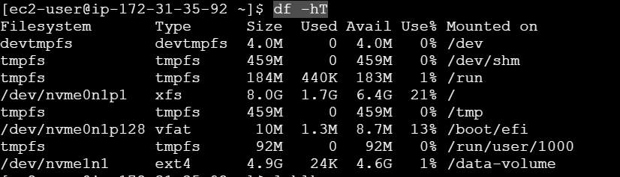
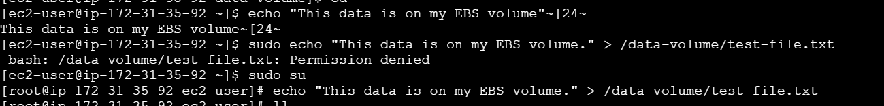
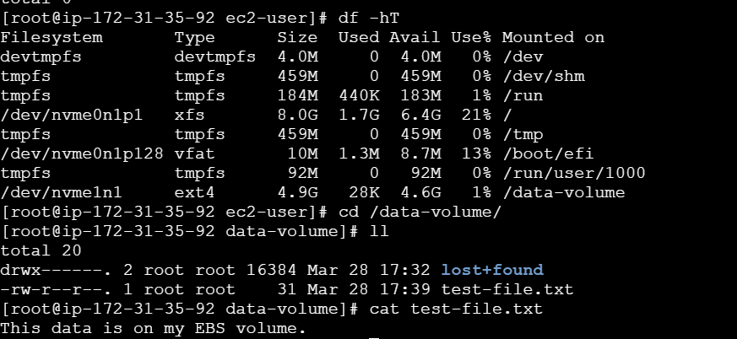
4.2 Attach to Windows
- Attach volume to Windows instance
- Configure inside Windows:
- Open Disk Management
- Initialize disk
- Create New Volume
- Format as NTFS
- Assign drive letter (e.g., D:)

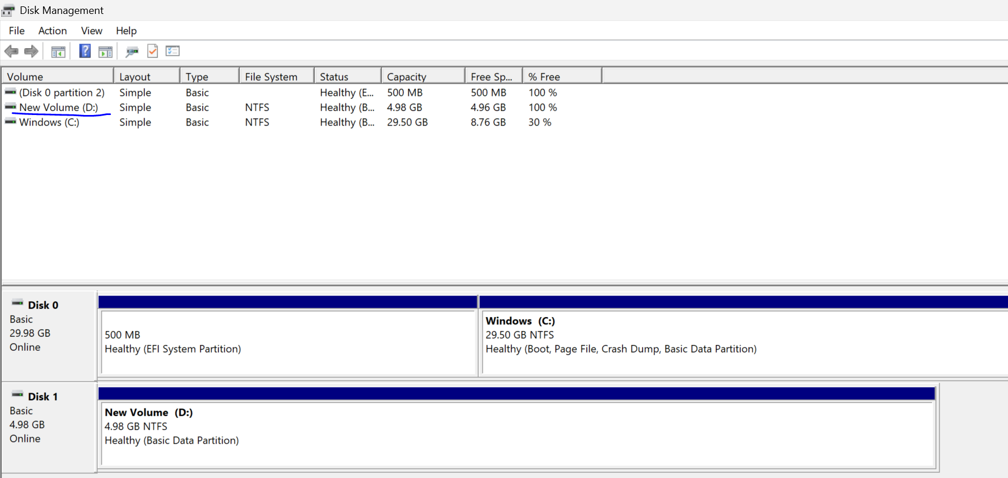
5. Create Snapshot
- Go to Volumes
- Select your 5 GB volume
- Click Actions → Create Snapshot
- Add description: EBS-Snapshot
- Click Create Snapshot
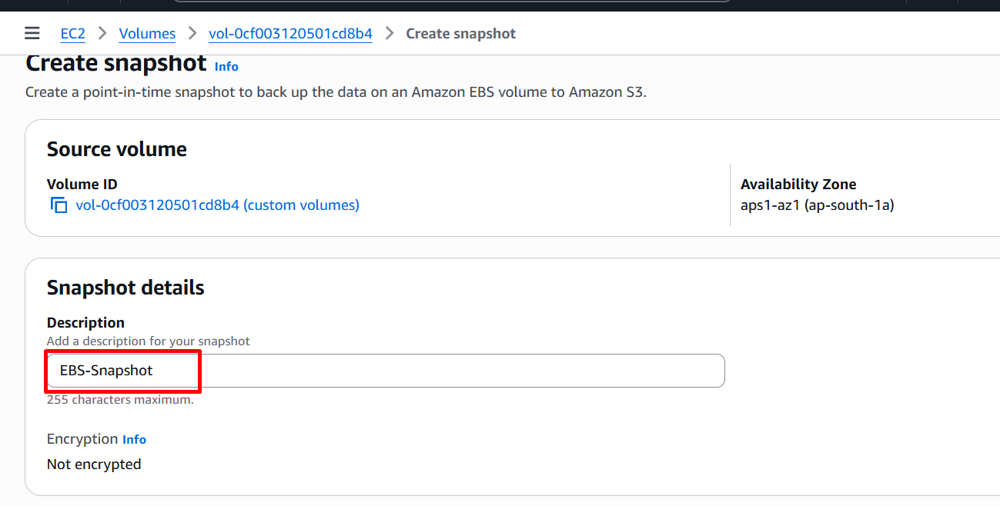
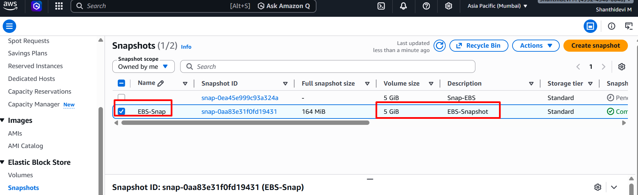

6. Create Volume from Snapshot
- Go to Snapshots
- Select snapshot
- Click Actions → Create Volume
- Configure:
  - Size: 5 GB (or more)
  - AZ: Same as instance
- Click Create Volume
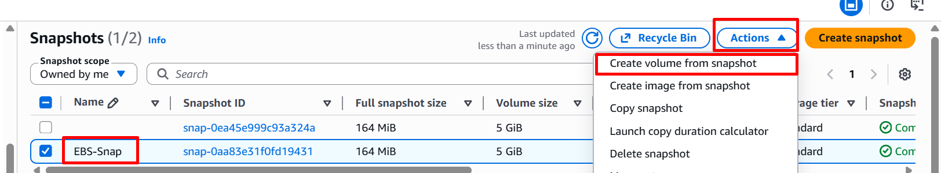

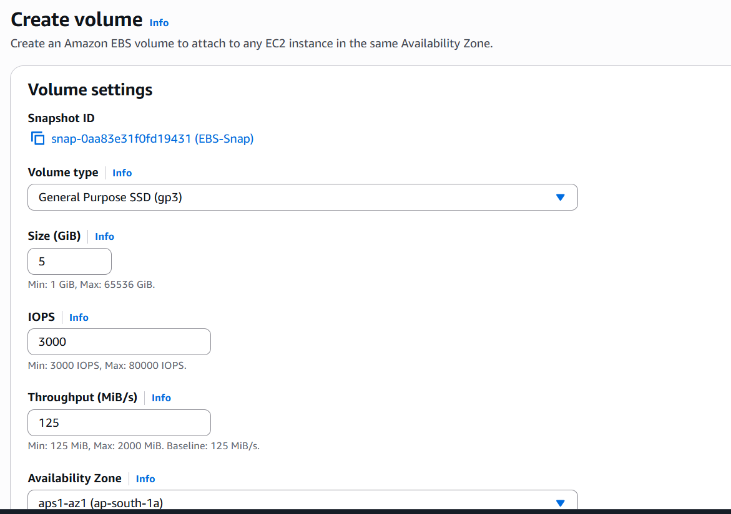
7. Attach New Volume
7.1. Configure inside Linux:
# lsblk
# sudo mkfs -t ext4 /dev/nvme1n1
# sudo file -s /dev/nvme1n1
# df -hT
# sudo echo "This data is on my EBS volume." > /data-volume/test-file.txt
# sudo su
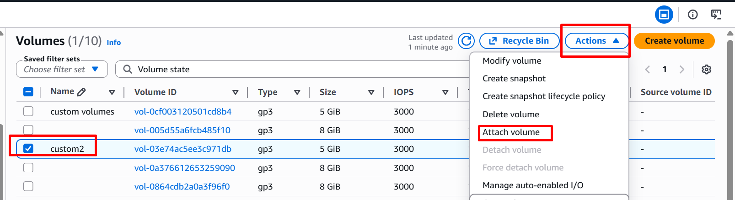

Repeat Step 4 to attach this new volume to EC2 instance and mount it.

